Chamber of Commerce SunUpper

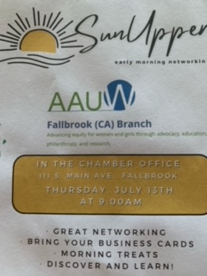
Chamber of Commerce member, Karen Trapane, helped us plan for the SunUpper, that will be featuring us Thursday, July 13, at 9 am where we would present all of the activities of our branch, with flyers and Sign-up sheets made available at the event.
Here is the flyer that the Chamber had created for us. KT said she will be supplying the food. All you need to do is show up and, hopefully, several of you can say a few short sentences to describe your role.

Update post meeting.

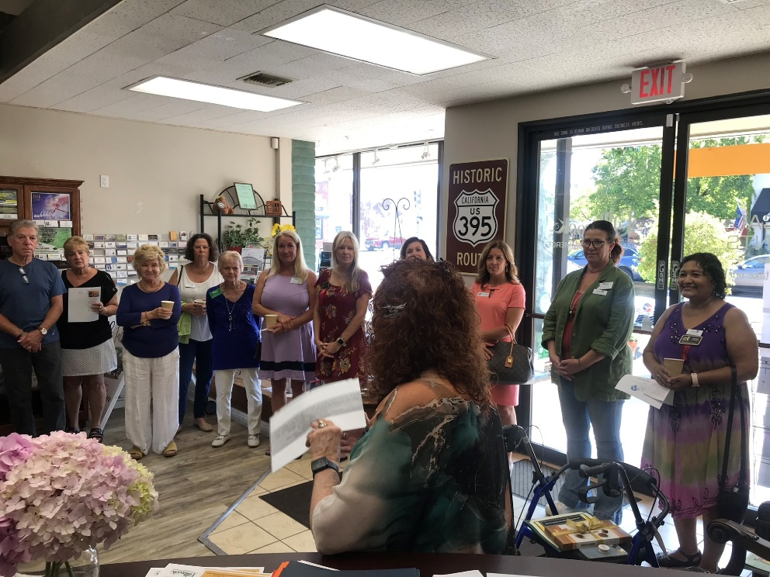
We had solid representation. Karen talked about AAUW and its mission as well as our mentorship program (the only one in the country) and how some of our mentees have come back years later to say that the speech contest played the most important part in their success as they were able to speak in front of groups with ease. Sharon Robinson talked about our fundraising and TechTrek program. Three people at the event decided to become members as a result of what they learned.

Receiving certificate from the chamber
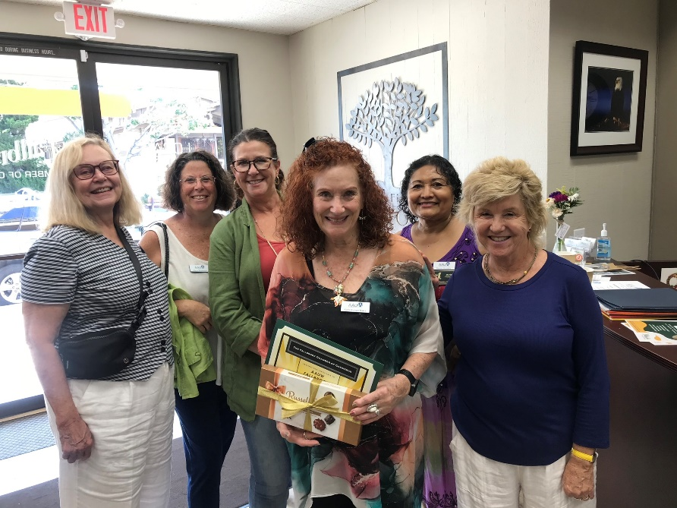

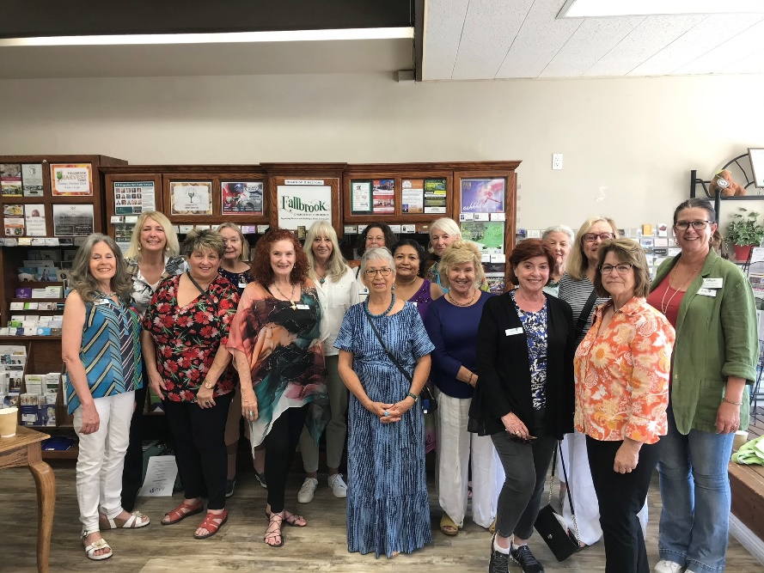
Group Photos (great turnout)
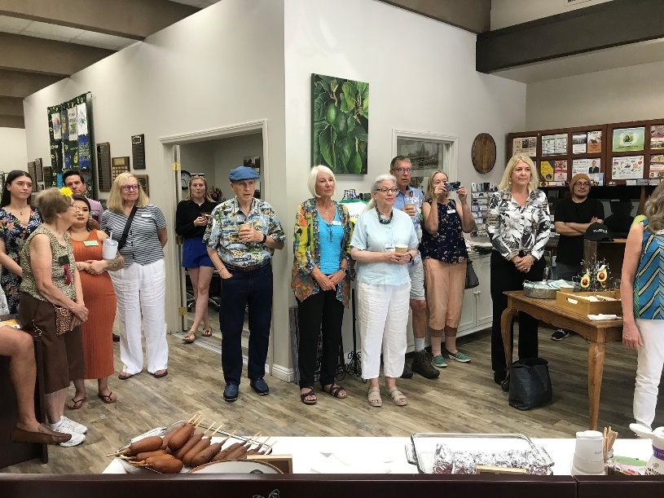
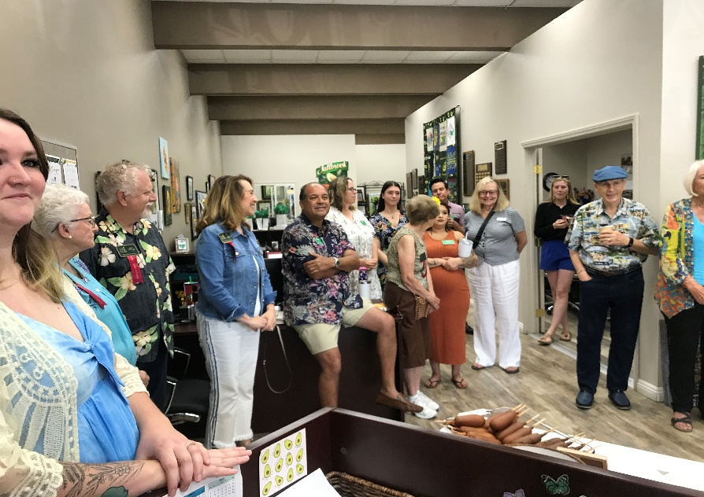
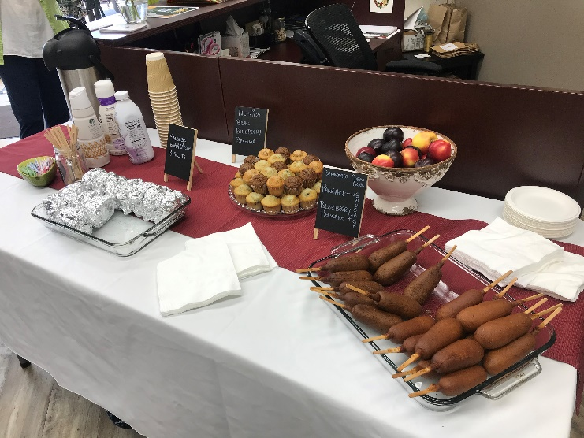

AAUW Board Meeting Minutes
AAUW Board Meeting Summary
There was no meeting scheduled July, 2023.
Upcoming Events
Saturday August 5 – NEW MEMBERSHIP BRUNCH Fallbrook Health District – Community Room. Doors Open 10:00, meeting begins at 10:30. Come join our new and existing member brunch. Feel free to invite a friend to learn more about us and hopefully join the group. Learn more and get updated about our mission and plans for the year. All our interest groups will present their group and have sign-up sheets.

Saturday September 9 – General Meeting. Fallbrook Health District – Community Room – Topic: Tech Trek.
Saturday December 9 - AAUW Holiday Party– MORE to COME

Public Policy

AAUW California Public Policy Committee Launches the “School Board Project”

There is a dangerous wave sweeping across our country to withhold certain historical information from students and to preclude student access and exposure to educational materials and/or campus events concerning a number of historically marginalized groups, including persons of color and people in LGBTQ+ communities. These efforts include financial and other forms of support for candidates for school board positions who support these policies and who would then be in a position to see them come to fruition.

These policies are antithetical to AAUW California’s public policy priorities to ensure “equal access to quality public education for all students” including “access to diverse curriculum that represents historically accurate information.” This is why AAUW California is determined to do everything we can to stop this movement from taking hold in our beautiful state, and why we have entered into a collaboration with Equality California to identify, recruit, and support candidates to run for nonpartisan school board races up and down the state.

On June 25, 2023, AAUW California Public Policy Chair Kathi Harper, along with a representative from Equality California, made a presentation to the Los Angeles IBC explaining the project. Learn more about the issue, what the project consists of, and how AAUW California members can help by listening to the recording included below.

Be part of the solution by completing a survey from the Public Policy Committee to help us determine whether this is or might become an issue in your community and to let us know if you are in this fight with us. The survey can be accessed HERE.

Fallbrook News

Special Election in High School Zone 1
Ballots will go out the week of August 21 to voters in Zone 1 of the Fallbrook High School District. This election can determine if we have a school board that wants to ban books and a diverse curriculum or one that is open and inclusive. Volunteers are needed to mobilize voters. If you can help to knock on doors, text voters or make phone calls let Joy know at joyfrew@gmail.com and I will pass it along to the candidate.

We are supporting Tauna Rodarte in this election. Our state contact, Seena Trigas, will be at our August meeting to talk about the project.

Video of Kathi Harper talk.

Joy
Public Policy Co-Chair

TECH TREK 2023 STAFF REPORT
I enjoyed my 11th year volunteering as Dorm Monitor at Tech Trek San Diego (UCSD). We had a good camp with many pivots to stay on track. It was wonderful to see many AAUW friends as our last San Diego in-person camp was in 2019. I am now officially trained to drive the electric carts and had fun driving staff and campers all over UCSD.
New Tech Trek Logo
Our 5 Fallbrook Branch campers each attended a weeklong 15-hour core class in either: Engineering, Robotics, Physics, Anatomy or Forensics. I was assigned to Engineering at the new Design and Innovation Building, adjacent to the new public transit station where the Coaster Train and Blue Line Trolley stop.

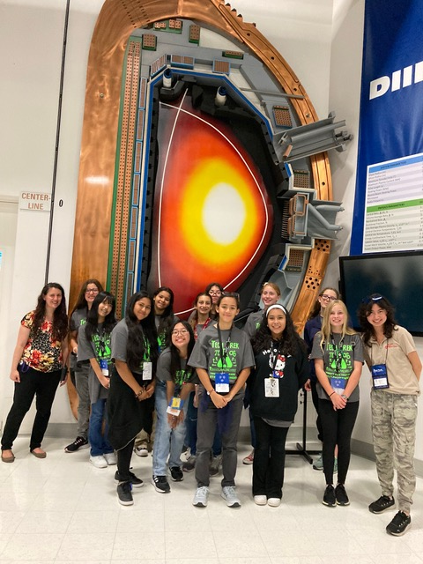

Each girl went on field trips to ViaSat, a satellite company in Carlsbad and to General Atomics Dlll-D National Fusion Facility where we saw a Tokamak. During the afternoons, each girl attended 6 workshops that included Robotics, Engineering, Chemistry and Physics. Evenings were busy with 4 seminars including “Raise Your Hands, Raise Your Voices” by Dr. “Mimi” Mary Isaac.

The group photo is at General Atomics in front of a demonstration cross-section of a Tokamak

Our fabulous dorms were located on the brand-new 6th College campus with our cafeteria on Muir College. Each girl is encouraged to sign up for the virtual Tech Trek Alumnae Community to stay connected with friends and participate in an engaging STEM community through school and college, including opportunities to volunteer for California Tech Trek.
To fulfill Fallbrook Branch adult staff requirement, I volunteered as Dorm Monitor (official name rather than “Dorm Mom”.) Duties of Dorm Monitors are monitoring the safety, timeliness and health of campers (campers selected to attend Tech Trek are expected to be self-monitoring in all these regards.)
Please ask me about volunteering at Tech Trek as ADULT STAFF IS NEEDED to help us maintain a required adult to minor ratio. We need AAUW Members to volunteer as Dorm Monitors, Students (age 18 or above) to volunteer as Senior Counselors/age 21 Dorm Monitors.

Susan Duling

Branch Webpage
Check out our Fallbrook Branch Webpage at www.Fallbrook-CA.AAUW.net
Newsletters, current event photos and updated information from Chairs are added ASAP.
To submit please EMAIL susancasoduling@yahoo.com: photos at LESS than 3 Mb and complete text as a WORD/PDF document.

Membership News

The traditional AAUW membership year has ended. If you haven’t renewed yet, please do so soon. The total renewal amount for one year is $112.00 ($72.00 National dues, of which $69.00 US tax deductible); $20.00 State dues and $20.00 Fallbrook branch dues. All three can be paid online.

To renew online, simply go to AAUW.org, log into your Personal Snapshot Page, and click “Renew” at the bottom of the screen.
If you haven’t set up your individual account on the AAUW - National website:
- Click on “Forgot Your Password” located below the blue login button.
- Enter your email address, then click “Reset Your Password” to receive a login email from info@aauw.org. (If you don’t receive it within 5-10 minutes, email connect@aauw.org)
- Enter your email address, and “Create and Confirm your Password” to access your Personal Snapshot page.
- Click RENEW at the bottom of the Snapshot screen to renew your national, branch and state memberships.

NOTE: If you prefer to pay by check, please bring it to the monthly meeting or send it to P. O. Box 1061, Fallbrook, Attention - Karen Trapane

Submitted by Karen Weisberger 2nd VP Membership

Book Club (Meets the 3rd Monday of the month at 10:30)
The Bibliobabes, as we affectionately call the members of our Fallbrook AAUW book club, continues to meet monthly.
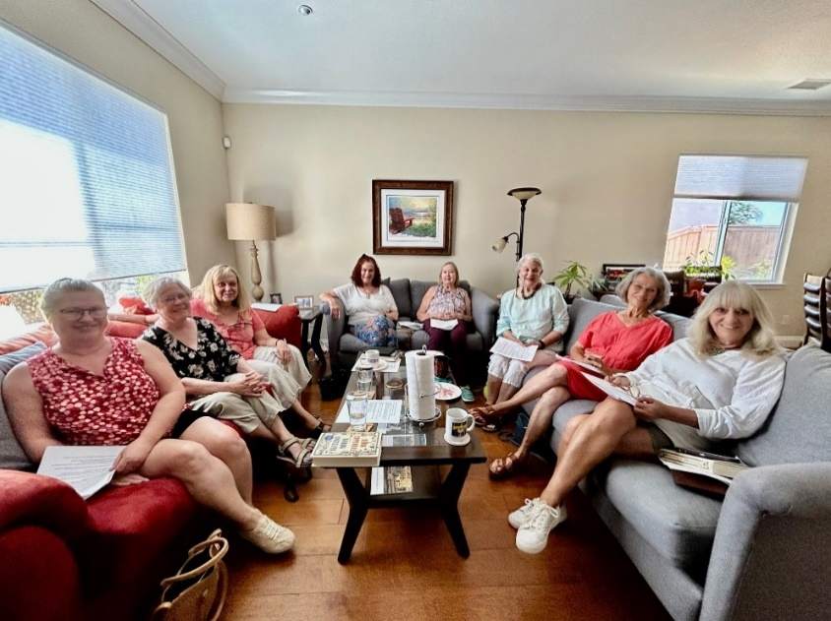

Stimulating discussion on Demon Copperhead by Barbara Kingsolver

L-R Ann McCarthy, Elizabeth Stuver, Margie Mosavi, Karen Langer Baker, Joy Frey (host), Rachel Rose, Cynthia Young, Lesley Ibaven (facilitator)

Next Meeting August 21 to discuss “Our Missing Hearts” by Celeste Ng

In a not-too-distant future, following economic and social turmoil, an authoritarian government has taken power in the US. Civil liberties have been rolled back. Wrung out by years of crisis, the population largely acquiesces in its loss of freedom. The country’s leaders stoke fears about the rise of China, pass draconian laws to enforce patriotic behavior, ban books and foment hatred against PAOs: People of Asian Origin.

Movie Group
The Movie Review Group will resume on Friday, September 15, with a pot-luck and a discussion of the blockbuster movie OPPENHEIMER. I encourage members to see it this summer. It is guaranteed 45 days in movie theatres through September 5. We have a hostess opening for the evening! Could that be you?

To be added or removed from movie review email notices, please drop a note to carole@carolehodges.com

During World War II, Lt. Gen. Leslie Groves Jr. appoints physicist J. Robert Oppenheimer to work on the top-secret Manhattan Project. Oppenheimer and a team of scientists spend years developing and designing the atomic bomb. Their work comes to fruition on July 16, 1945, as they witness the world's first nuclear explosion, forever changing the course of history.

Walking Group
We are on break - stay tuned. Carolyn Thom

AAUW Fallbrook CA Branch
Officers and Committee Chair for 2023-4

Elected Officers:
President Karen Langer Baker karenlangerbaker@gmail.com
1st VP, Programs Patty Carlson poochielyn444@gmail.com
1st VP Programs Dianne Summers dianesummers04@gmail.com 2nd VP Membership Karen Weisberger karen.weisberger@gmail.com
2nd VP Membership Rachel Rose rachelroseboston@yahoo.com
Finance Officer/Funds Karen Trapane ktrocks25@gmail.com
Recording Secretary Margot Dokken nevehmind@gmail.com
Parliamentarian Elizabeth Leader Elizabeth,leader @gmail.com
Appointed Chairs:
AVID Mentorship Program Marli Shoop marlishoop@comcast.net
Corresponding Secretary Susan Duling susancasoduling@yahoo.com
Directory Rachel Rose rachelroseboston@yahoo.com
Diversity Diane Summers dianesummers04@gmail.com
Historian Nancy Heins-Glaser misswiss1965@gmail.com
Hospitality Maria Viernes maria_viernes@yahoo.com
Alice Orr alliekorr@yahoo.com
Newsletter Editor Lesley Ibaven. lesleyibaven@gmail.com
Nominating Karen Trapane ktrocks25@gmail.com
Photographer Nancy Heins-Glaser misswiss1965@gmail.com
Public Policy Joy Frew JoyFrew@gmail.com
Ann McCarthy ann.mccarthy120@gmail.com
Public Relations/Publicity Margie Mosavi margaret.mosavi@gmail.com
Scholarships Susan Schaeffer susieschaeffer@gmail.com
Strategic Planning Pamela Nevills panevills@earthlink.net
Tech Trek Sharon Robinson sharonrobinsongroup@gmail.com
Website Manager Susan Duling susancasoduling@yahoo.com
Special Interest Chairs:
Book Group Cynthia Young mscynyoung@gmail.com
Walking Group Carolyn Thom carolynthom1@gmail.com
MahJong Group Kathy Bierbrauer ckbierbr@gmail.com
MahJong Tournament Kathy Bierbrauer ckbierbr@gmail.com
Araxy Moosa araxymoosa@gmail.com
Movie Review Group Carole Hodges carole@carolehodges.com
Special Events
Arts in the Park Carolyn Thom carolynthom1@gmail.com
Career Day Marli Shoop marlishoop@comcast.net
Christmas fundraising party Diane Summers dianesummers04@gmail.com
Scarecrows Nancy Heins-Glaser misswiss1965@gmail.com
Silent auction fundraising Carole Hodges carole@carolehodges.com
Speech Contest Marli Shoop marlishoop@comcast.net
Speech coaching Ann McCarthy ann.mccarthy120@gmail.com

