Fallbrook CA Branch  P.O. Box 1061, Fallbrook CA 92088–1016  Website: fallbrook-ca.aauw.net | Women with Vision  volume 40, issue 2 August 2023  Celebrating Our 77th year!
Young women with dreams become women with vision
Our Mission: To advance gender equity for women and girls through
research, education, and advocacy.
Our vision: Equity for all.
Our values: Nonpartisan, fact-based, integrity, inclusion, and intersectionality.

President’s Message

In my first message to you as your new president, I want to extend a very warm welcome back as I also welcome all of you new members to our wonderful group of dedicated women who are truly making a difference!
We are now offering free Fallbrook AAUW membership to mentees as long as they are high school or college students. Mentors: please contact your former mentees who are still in college to invite them back!
We have a full slate of officers and chairs of committees, including Patty Carlson, as our new President-elect, first vice president and cochair with Diane Summers of programs. New second VPs and cochairs of membership are Rachel Rose and Karen Weisberger. Margot Dokken is our recording secretary. Karen Trapane is continuing as our finance officer. She will also be in charge of our fundraising efforts. Continuing are corresponding secretary and website manager Susan Duling and parliamentarian Elizabeth Leader.
Our new Director of the mentorship program is Marli Shoop. Susan Schaeffer will head up the scholarship committee and Sharon Robinson is taking over the position of TechTrek Director. A new position has been filled and is already very active: Pamela Nevills held her first successful meeting with the entire board for strategic planning.
Continuing as chairs of the following are: diversity/Diane Summers; historian and

photographer/Nancy Heins-Glaser; hospitality/Maria Viernes and Alice Orr; newsletter/Lesley Ibaven; Public Policy/Joy Frew with Ann McCarthy coming on board;

public relations and publicity/Margie Mosavi; book group/Cynthia Young; walking group/Carolyn Thom; mah-jongg/Kathy Bierbrauer; and movie review group/Carole Hodges.
Although all of our chair positions are filled, there is always room to add more of you in some capacity. Feel free to contact any of us to become involved.
I look forward to a fulfilling and rewarding year!

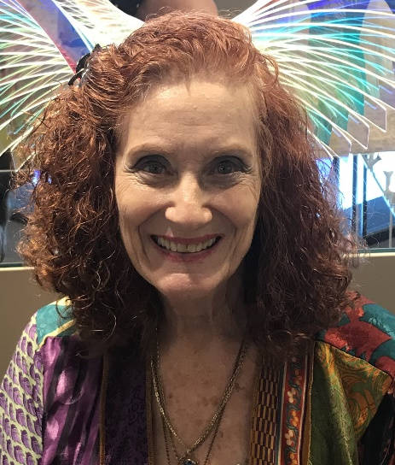

Karen Langer Baker
President Elect

Table of contents

President’s Message – 1-2
Table of Contents - 3
Fallbrook AAUW Strategic Review -4
Strategic Review Brainstorming Session – 4-8
Building the “young reader’s BRAIN” – 8
August/September Birthdays – 10
Chamber of Commerce Sun Upper – 11-12
AAUW Board Meeting Minutes – 10
Public Policy - 13
Tech Trek – 15-16
Branch Webpage – 16
Membership News - 17
Clubs – 18-19
Officers and Committee Chairs - 20

Fallbrook AAUW Strategic Review – Saturday, July 8, 2023
On July 8th new and previous board members met to engage in a strategic review of activities for Fallbrook AAUW. After acknowledging both National and State plans and goals the ladies reviewed our local branch, looking at five areas: opportunities, threats, visibility, fund raising, and scholarships. Groups of three members reviewed each topic and made recommendations to be reviewed by the new board members. The results of this meeting will continue to be developed during the next year.
Certainly, the final part of the meeting gave an opportunity to eat, talk, and get to know new members to the board. Everyone brought a salad or a dessert for the luncheon.
The new board held a meeting following lunch. Members will be advised as this process develops.
Brainstorming Session
Topic Summaries
A. Are there opportunities that are missed by our Branch?
Strengths: Large, energetic membership
Weaknesses: Do not know the talents of the members
Opportunities: more participation with mentees: pack-a-lunch (girls and/or ladies), Gov Tech involvement, public policy person on board
Threats: inclusive, non-patrician, education-based membership
Recommendations:
- Gov Trek participation, get speaker on this topic.
- Assist in local Education Board elections for candidates that are aligned with AAUW intent and mission
- Outreach to pubic programs for the good of the community, such as CPR.

B. What threatens the longevity of our Fallbrook Branch? And, what can we do about it?
Strengths: Active and friendly membership
Weaknesses: Older members, not engaging younger members or mothers of younger children.
Opportunities and Recommendations:
- Contact and have presence at local colleges (Mira Costa, Palomar, UC San Marcos). Invitations to meetings, free student memberships,
- Digital subscriptions to the AAUW Fallbrook monthly Newsletter,
- Have a booth at the Avocado Festival,
- Continue to sponsor a Sun Uppers event,
- Include husband supporting membership, $20. With no voting or holding a position,
- Have family fun times sponsored by AAUW, Date night, AAUW mentees and mentors to babysit. Rem: dues or donations go to Scholarship Fund to be tax deductible.
C. How can we be more visible in the community?
Strengths: Valley News, Everything Fallbrook
Weaknesses: Showing up at community events
Opportunities: A better writing campaign: membership event, scholarship, Chamber of Commerce
Threats: no donors, lack of younger members
- Recommendations:
- Contact school teachers
- Stickers in Stores or cars
- Letter writing
- Walk in local parade
D. Scholarships have been given to large numbers (10 and 11) young women the last couple of years. Should larger amounts be given to fewer applicants or stay with this pattern?
Strengths: the amount of money given, committee commitment
Weaknesses: weak interview questions, need to know their goals and career pathway, financial needs (this information was available on the applications and score sheets we used – Pamela)
Opportunities: AVID
Threats: Committee cooperation
Recommendations: note these recommendations will be placed in the Scholarship information that is passed on to the new chairperson. However, the board may want to set a policy for the awarding of these funds.
- Include applicants who plan to go to 2-year college
- Progressive distribution
- Limit to 5 scholarship awards
- Very clear calibration of application information and interview scores
- Contact from recipient junior year to continue financial support.
E. How can Fund Raising and Leadership Training for Tech Trek and Scholarship be built into our year?
Strengths: Holiday party, well established, keep it, Baskets with party, continue to encourage yearly larger-amount donors
Weaknesses: no goals for Fund Raising, thinking is too small, need fundraising options outside the members
Opportunities: One TEDX event at Mission Theatre (cost? Ticket price? Encourage Chamber support, free event for under 18, develop a calendar early for the year, have a live auction with donations that do not have to be new, repurposing is ok, Fun Event in February or March, could auction “dinner for six”
Threats: lack of interest, support to fund programs, watch community and school calendars, some projects are under-represented and people become overwhelmed.
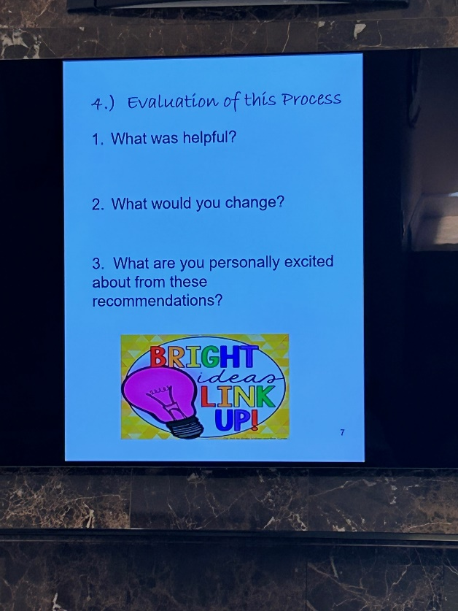
A four-step process was employed to identify strengths, weaknesses, opportunities, and threats (SWOT). Following short small group discussions, we reconvened to evaluate the process, which included what had been helpful, what we would change, and our level of personal excitement about these recommendations.
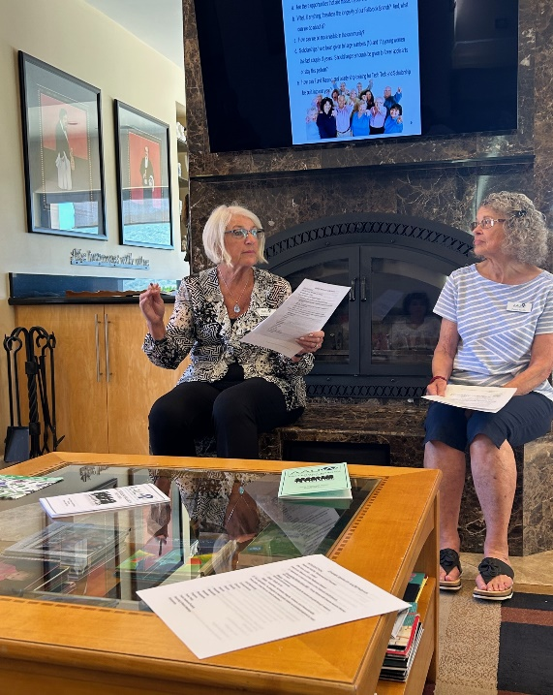
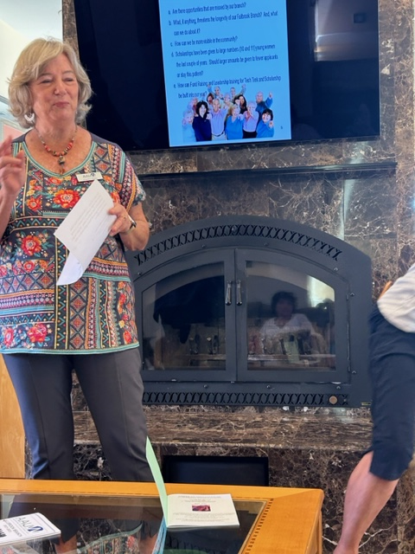

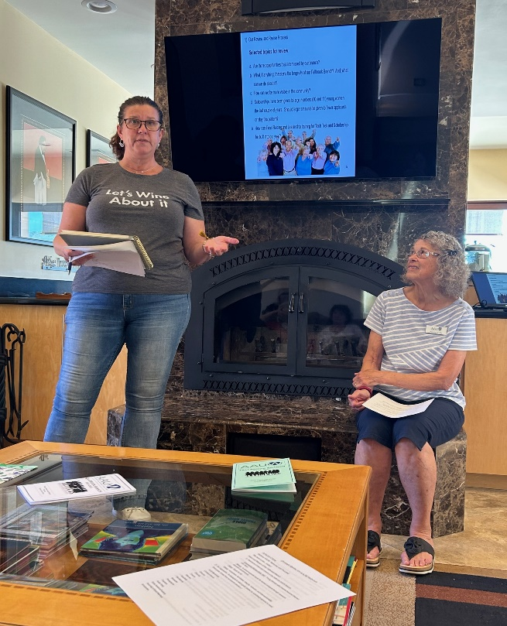

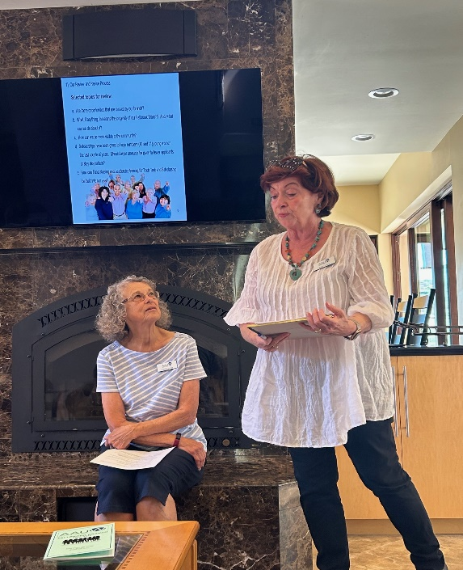

In attendance were former president and current public relations/publicity chair Margie Mosavi; current president and former mentorship program Director Karen Langer Baker; President-elect and 1st VP/programs co-chair Patty Carlson; 1st VP/programs co-chair plus diversity committee and red stocking event chair Diane Summers; former 2nd VP/membership chair Carlene Friesen; current 2nd VPs/Membership co-chairs Karen Weisberger and Rachel Rose; finance officer and fundraising chair Karen Trapane; former recording secretary and current strategic planning chair Pamela Nevills; current recording secretary Margot Dokken; current mentorship Director Marli Shoop; hospitality co-chair Alice Orr; public policy chair Joy Frew; former fundraising chair and current TechTrek chair Sharon Robinson; walking group chair plus scholarship committee and mentorship program assistant Carolyn Thom; and movie group plus silent auction chair Carole Hodges.
After the recommendations were presented to the large group, we were asked to evaluate the process.

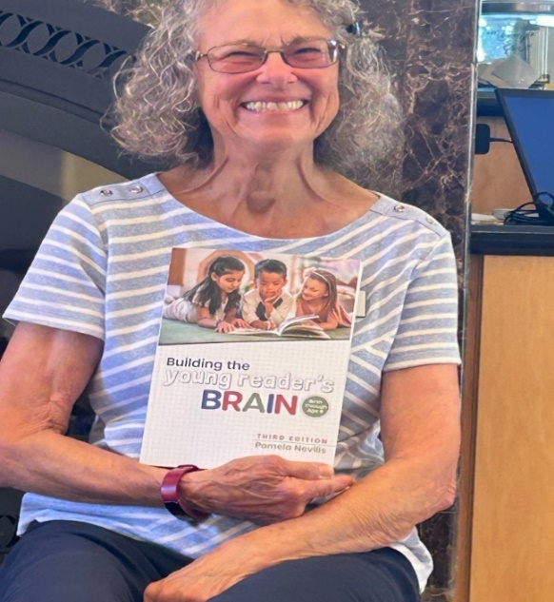
Pamela‘s book, “Building the young reader’s BRAIN,” has now been published!

Pamela had squeezed fresh orange juice from her trees which we enjoyed during the meeting, along with coffee cake, coffee, and orange infused water. After the formal meeting, we enjoyed a sumptuous Buffet of salads and desserts provided by each of us. Afterwards, we were given containers with a variety of the leftover salads plus avocados, oranges and lemons from Pamela‘s trees. She even gave each of us a small planted succulent from her garden!

The executive board had a short meeting after everyone else had left. It was a full and very satisfying day from beginning to end.
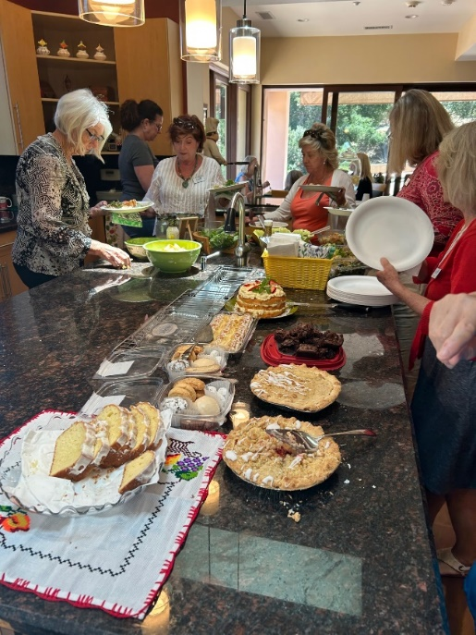
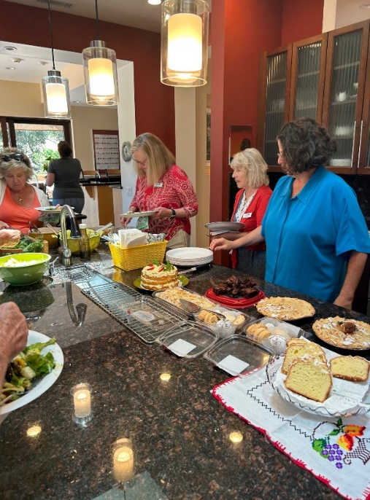

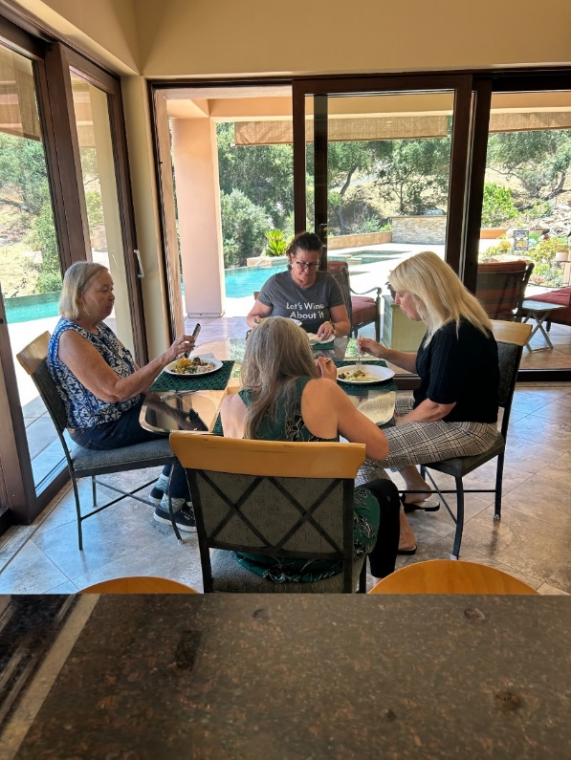
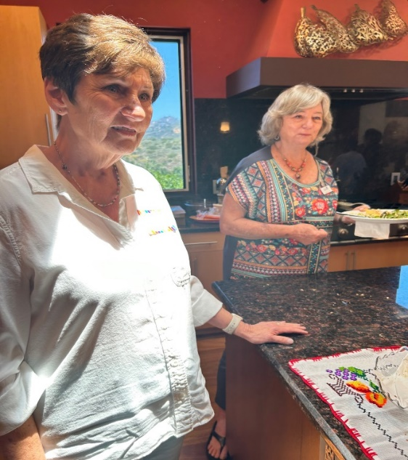

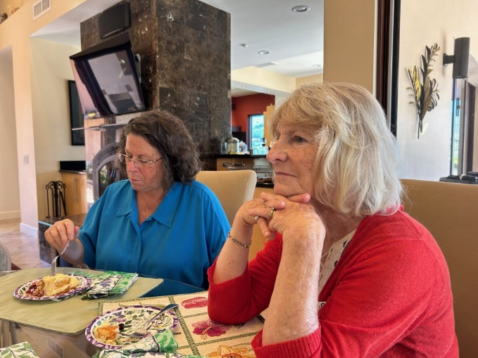

August/September Birthdays

August 5 Maria Viernes
August 19 Marilee Ragland
September 1 Rachel Rose
September 4 Elizabeth Leader
September 17 Grace Vander Werf
September 23 Margie Mosavi

Contact Susan Duling, Corresponding Secretary if you know of a member who needs a card or note: susancasoduling@yahoo.com or text 760-390-6069

